**«| Federal Office I for Migration**

**I and Refugees**

1? S +

Important information for applying for asylum in Germany Englisch

This fact sheet contains helpful information for asylum seekers taking the first steps in the asylum procedure.

**Very important:** Follow the instructions you are given by the public authorities. This is the quickest way to start the asylum application. There is no future in Germany without acceptance in the procedure.

**ASYLUM SEEKER** WHO ARE YOU?

Step 1: Report to a public authority

As soon as you arrive in Germany, report to a public authority, such as the police. Say that you would like to apply for asylum. Follow the instructions of the staff. They will refer you to accommodation

in a nearby reception centre. If you do not report to the authorities, you are in Germany illegally and

run the risk of being deported!

Step 2: Go to a reception centre

You will be accommodated initially in the nearest reception centre for asylum seekers.

You will be taken care of here and given the information you need. You will be issued with a certificate of registration as an asylum seeker („Bescheinigung uber die Meldung als Asylsuchende“). This step is necessary.

You are required to give information about your identity and your asylum application cannot proceed without it.

|  |  |  |
| --- | --- | --- |
| **' c AND** | **5ERMAN' ITS FED STATES** | **ERAL** |
|  |  | *J* |

Step 3: Await your federal state allocation

You cannot choose which federal state to stay in. You will be allocated accommodation in a federal state. This decision is binding. All asylum seekers need to be divided evenly among the 16 federal states so that requests for protection can be processed quickly.

You may therefore be required to travel to a different federal state. Please do not oppose this decision otherwise your asylum application cannot be duly processed and this would jeopardise your legal residence status in Germany!

The Federal Office for Migration and Refugees (Bundesamt fur Migration und Flucht- linge - BAMF), which decides on your asylum application, has offices in all 16 federal states. The same rules are applied in the asylum procedure everywhere in Germany.

exceptional cases, personal circumstances may be taken into consideration when deciding on the distribution (e.g. close family ties).

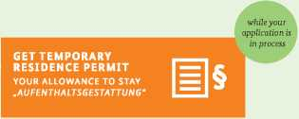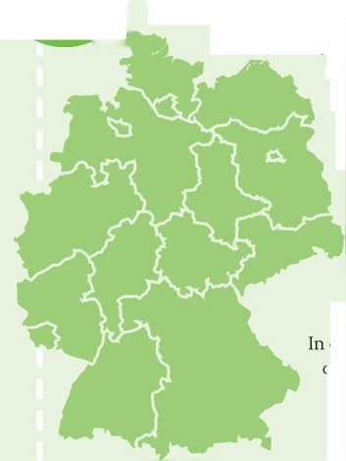

| *f* **RECEPTION**  **CENTRE**  **JI** |
| --- |
| **lH\*** |

**Step 4: Go straight to the reception centre to which you are directed** The reception centre to which you are directed is responsible for your subsistence, accommodation and health care. You will also be given information there about the next steps in the procedure and you will be told which BAMF office is dealing with your case. It is usually close to the reception centre. Only in this

reception centre are you guaranteed a means of subsistence.

Step 5: Submit your asylum application

You are required to submit your asylum application in person at the BAMF office. The office will keep a record of your personal data. You will be photographed and your fingerprints will be taken (except in the case of children under 14 years of age). This is a requirement for the issue of the residence permit (identification document). This document is proof of your status as an asylum seeker for the public authorities and shows that you are a legal resident in Germany. If you cannot furnish this proof, you may be forced to leave Germany.

J

FEDERAL OFFICE FOR MIGRATION AND REFUGEES

BRING ALL PERSONAL DOCUMENTS

PASSPORT, BIRTHCERTIFICATE, ETC.

AND ALL

TRAVEL DOCUMENTS

TICKETS,

QUITTANCES, ETC.

WE TAKE FINGERPRINTS

THIS HELPS US TO IDENTIFY YOU

AND A PHOTO

THIS ALSO HELPS TO IDENTIFY YOU AND TO PROVIDE VALID DOCUMENTS

Step 6: Await the decision as to which country in the European Union is responsible for your asylum application

The BAMF office will check if Germany or a different country is responsible for your asylum application. This check is based on the Dublin Regulation and is applicable in the countries of the European Union (EU), Nor­way, Iceland, Switzerland and Liechtenstein. This check is carried out to avoid duplication and to make sure that each asylum application is processed by just one country within the EU. The BAMF office will therefore ask you when and where you arrived in the EU and will ask you to give reasons against a transfer to the Member State responsible for your application.

F

DUBLIN REGULATION

It is essential for you to register in the country which you enter first. Many families are separated en route - only by registering is it possible to bring families back together.

Step 7: Await assessment of your asylum application if Germany is in charge of your application

FFEODREMRAIGLROAFTFIIOCNE

You will be interviewed in person by BAMF staff and asked to give your reasons for seeking asylum. Interpreters will be available who are sworn to confidentiality. You can arrange for a lawyer to be present at your hearing. After the hearing, the BAMF office will check whether you are eligible for asylum in Germany based on the reasons you

**TELL US YOUR REASONS FOR APPLICATION**

**WHERE ARE YOU FROM?**

**WHAT HAS HAPPENED TO YOU? DON'T WORRY, THERE WILL BE A TRANSLATOR.**

have given.

You will receive written notification from the BAMF office on the decision on your asylum applica­tion. If your application is judged to be valid, you will be issued with a temporary residence permit. After three years you will be issued with a permanent settlement permit if your eligibility criteria

**GET YOUR DECISION**

**ON YOUR APPLICATION**

**THE DECISION WHETHER YOU I I Q**

**HAVE THE RIGHT FOR ASYLUM I I \*\***

**OR NOT**

still apply.

If the final decision is to refuse your application, you will be required to leave Germany by the date specified. If you fail to leave within the specified period, you will be repatriated by force if necessary.

Imprint

**Published by:** Federal Office for Migration and Refugees (BAMF), Frankenstr. 210, D-90461 Nurnberg,

[info@bamf.bund.de](mailto:info@bamf.bund.de), [www.bamf.de](http://www.bamf.de), Tel. +49 911 943 - 0, Fax +49 911 943 - 1000, [www.bamf.de/inforefugees](http://www.bamf.de/inforefugees), **Last updated:** October 2015

